

Employee Productivity Analysis

Report

**Contents**

|  |  |  |
| --- | --- | --- |
| **Sr.No** | **Section** | **Page No.** |
| **1.** | **Title** | **3** |
| **2.** | **Objective** | **3** |
| **3.** | **Executive Summary** | **3** |
| **4.** | **Observations** | **4** |
| **5.** | **Dashboard Overview** | **7** |
| **6.** | **Conclusion: Insights, Recommendations, Future Improvements** | **9** |
| **7.** | **Appendix: Data Source & Preparation, Decision Visuals Used, Challenges & Solutions** | **10** |

# Title

**Employee Productivity Analysis Report**

# Objective

This report analyses employee productivity trends and identifies key factors affecting individual efficiency. It focuses on evaluating the influence of training frequency, satisfaction levels, departmental distribution, and overtime hours on productivity. The analysis supports HR teams in refining training strategies, satisfaction improvement initiatives, and time allocation practices to enhance measurable employee performance.

# Executive Summary

Analysis of the dataset revealed that only **26.3%** of **employees** operate at full **(100%) productivity**, while **38.6%** remain at a **60% productivity** level. **Productivity** **increases** **directly** with the number of **training** **sessions** attended. For instance, employees with **four training** **sessions** reached **27.1%** productivity, compared to just 1.03% among those with no training.

**Satisfaction levels** show a **non-linear relationship** to output—**neutral** employees record the lowest **productivity (24.93%)**, while both **satisfied** and **dissatisfied** **employees** average nearly the same performance **(~37.5%)**. **Overtime** **contributes** **positively** to project completion up to a range of 22–29 hours per year, where the highest number of **projects (26.83%)** is observed.

# Observations

* **Departmental Distribution**: **Marketing**, **Finance**, and **Operations** departments each account for approximately **11.2%** of the employee base, showing the **highest** **concentration**.

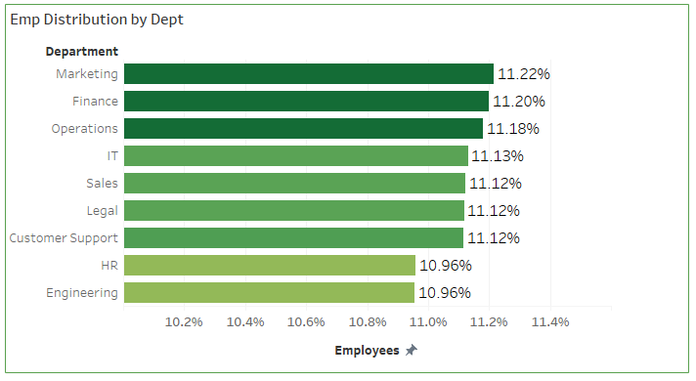

* **Productivity Levels**:
  + **38.6%** of **employees** operate at **60% efficiency**.
  + **26.3%** reach **100% productivity**.
  + Only **7.3%** of employees reach the **80% level**.

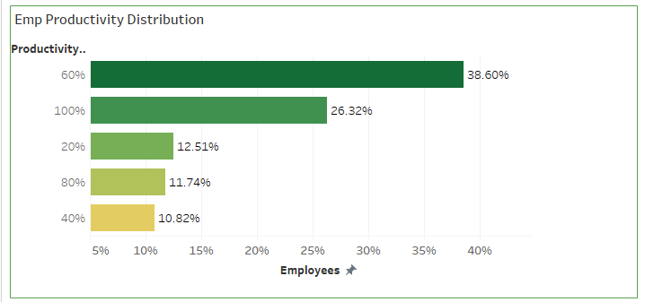

* **Satisfaction Levels**:
  + **24.93%** productivity observed in **neutral** employees.
  + **Satisfied** employees: **37.58%** productivity.
  + **Dissatisfied** employees: **37.48%** productivity.

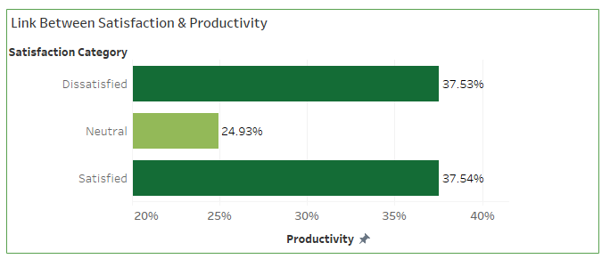

* **Training Sessions**:
  + Employees attending **four** **sessions**: **27.1%** productivity.
  + **One** training **session**: **6.5%.**
  + **No training: 1.03%.**

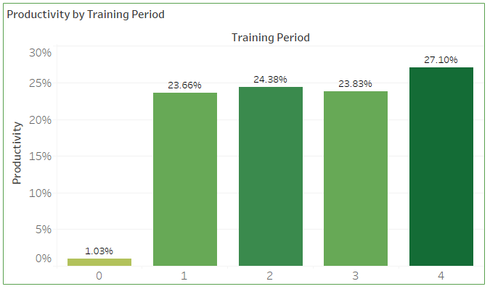

* **Overtime Hours**:
* Employees working **22–29 hours** of **overtime** complete **26.83%** **of all projects.**
* Employees with **less than 10 hours** of **overtime** contributed significantly **less** to **project** **completion**, indicating a direct link between moderate overtime and higher output.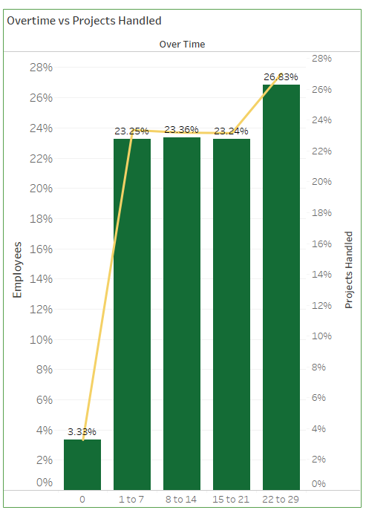

# Dashboard Overview

The Tableau dashboard was built using pre-processed data, focusing on direct relationships between employee metrics and productivity outcomes. Key components:

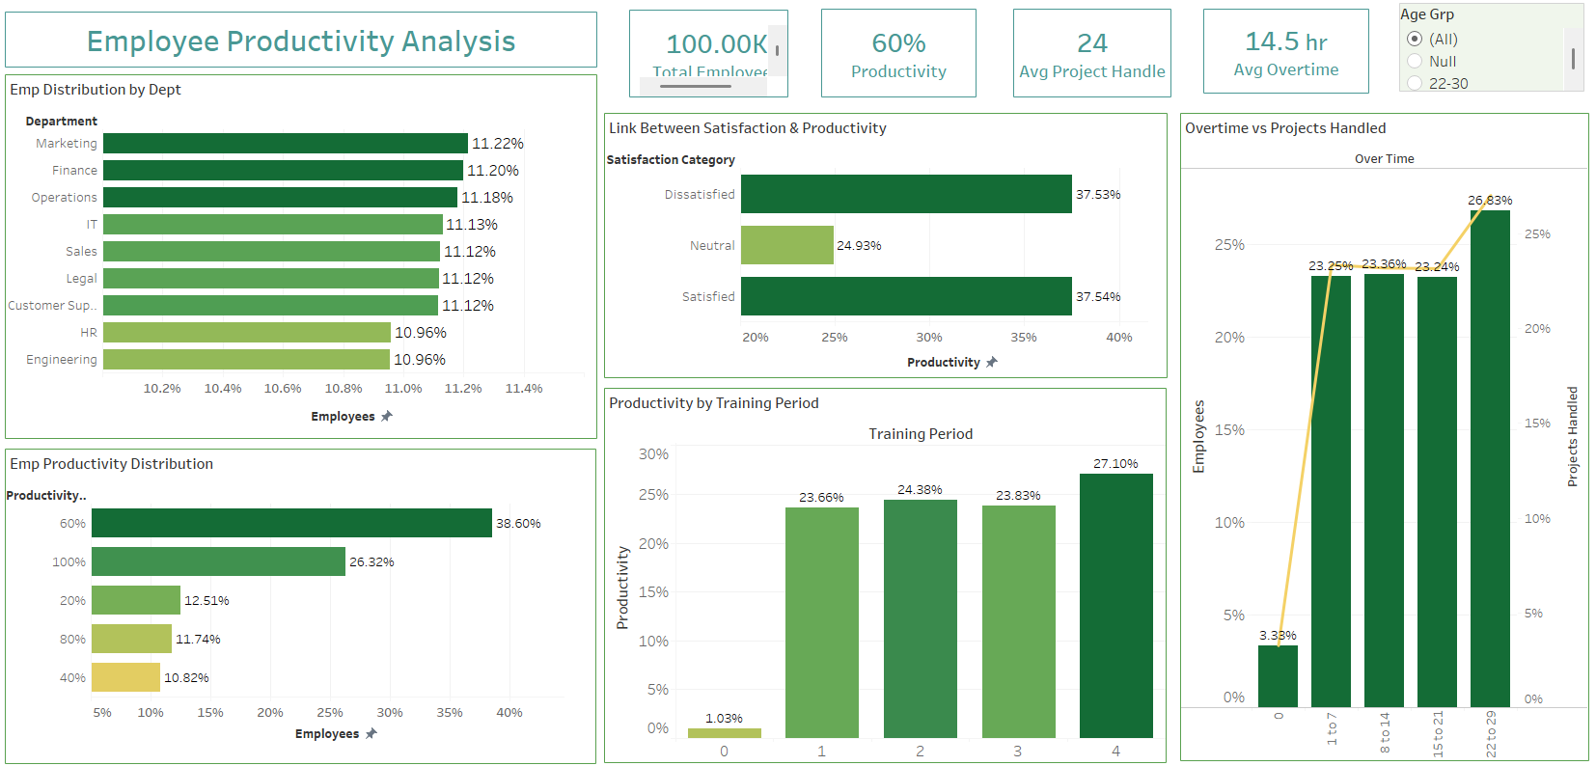

**Visualizations:**

* **Bar Charts:**
  + Departmental employee count.
  + Productivity variation based on training count.
  + Satisfaction level vs. productivity.
* **Stacked Bar Charts:**
  + Productivity tier segmentation across departments.
* **Combo Graphs (Line + Bar):**
  + Overtime hours mapped against project completion numbers.
* **KPI Cards:**
  + Total Employees: 1,499
  + Average Projects per Employee: 3.85
  + Avg. Productivity Score: 61.24%
  + Avg. Overtime Hours: 18.5

**Interactive Filters:**

* Department
* Age Group
* Satisfaction Level
* Training Period
* Overtime

Each visualization also acts as a drill-down filter, enabling correlation-specific investigation by user selection.

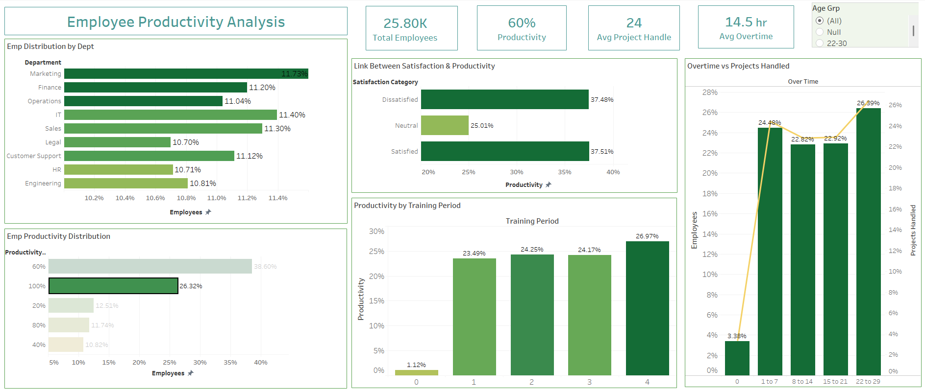

# Conclusion

**Insights**

* Marketing, Finance, and Operations have the most employees (~11.2%) but are not the most productive.
* Employees with **4 training sessions** have the highest productivity (**27.1%**).
* **Neutral satisfaction** aligns with the lowest productivity (**24.93%**); satisfied and dissatisfied employees perform similarly (~**37.5%**).
* Overtime between **22–29 hours/year** results in the highest project output (**26.83%**).

**Recommendations:**

* Set minimum training sessions to **at least 2** per quarter for low-performing employees.
* Conduct targeted surveys to convert **neutral** satisfaction scores to **positive**.
* Cap overtime at **30 hours/year** to maintain productivity without triggering burnout.

**Future Improvements**

* Connect the dashboard to live data for real-time updates.
* Add employee feedback and sentiment tracking.
* Use predictive models to spot drops in productivity early.
* Set alerts for low productivity or high overtime trends.

# Appendix

**Data Source & Preparation:**

* **Source**: Public dataset from Kaggle, including fields like employee ID, department, satisfaction level, number of trainings, overtime hours, and project count.
* **Preparation Steps**:
  + Removed 47 duplicate records.
  + Handled 32 missing numeric values with mean imputation; 21 missing categorical values replaced using mode imputation.
  + Created a new field Productivity Tier (20%, 40%, 60%, 80%, 100%) based on performance index.
  + Reformatted for Tableau compatibility using structured CSV.
* **Visuals Used:**
* 3 Bar Charts (Distribution, Training vs. Productivity, Satisfaction vs. Productivity)
* 1 Stacked Bar (Productivity Tier by Department)
* 1 Line-Bar Combo (Overtime vs. Projects)
* 4 KPI Summary Cards
* 5 Filter Panels (age, dept., satisfaction, overtime, training)

**Challenges & Solutions**

* **Missing Data**: Filled using averages for numbers and most common values for categories.
* **Productivity Categories**: Created clear tiers (20% to 100%) to group employees.
* **Dashboard Filters**: Made charts interactive for easier analysis.